SIMATS ENGINEERING (SAVEETHA SCHOOL OF ENGINEERING)
Department of Artificial Intelligence and Data Science
ASSESSMENT TOOL 2 – Case Study

Course Code: | DSA0307 | Course Title: | Natural Language Processing
CO Assessed: | CO3 – Precision | Assessment: | Assessment Tool 2 – Case Study
Weightage: | 40% of CIA
CO5 Statement: | Apply N-gram models, smoothing techniques, part-of-speech tagging systems and to evaluate effective syntactic analysis. (BL-3)
Student Name: | S.Sri Sai Prasanna Durga | Reg. No.: | 192424241
Section / Batch: | 2024 | Date:

Code of Conduct
I______S.Sri Sai Prasanna Durga (192424241)___ (Name / Reg No) certify that this submission is my original work and that I have adhered to the guidelines specified for this assessment. I understand that any violation of academic integrity rules will result in disciplinary action.
Signature of the Student: __S.Sai Prasanna_______________________

Instructions
- Read all three case studies carefully before attempting the questions.
- Provide appropriate justifications and interpretations for every computed result.
- Use NLP concepts, algorithms, and terminology wherever applicable.
- Diagrams, flowcharts, tables, or mathematical formulations may be used to support your answers.
- Duration: 30 minutes.

Section / Topic | Focus | Case Study
N-Gram Language Models and Smoothing Techniques | Bigram and Trigram probability computation, Maximum Likelihood Estimation (MLE), Backoff models, Deleted Interpolation, Entropy calculation, uncertainty analysis, real-time next-word prediction | Case Study 1 – Smart Mobile Keyboard Prediction System
Part-of-Speech (POS) Tagging and Word Classes | Penn Treebank tagset, contextual ambiguity resolution, rule-based tagging, stochastic tagging (HMM), emission and transition probabilities, word class identification, chatbot language understanding | Case Study 2 – AI-Powered Customer Support Chatbot
Transformation-Based Tagging (Brill Tagger) | POS tag correction, transformation rules, contextual tagging, linguistic validation, tag sequence refinement, ambiguity handling | Case Study 3 – News Analytics and POS Tag Correction System
Corpus Statistics and Probabilistic Analysis | Word frequency counting, corpus-based probability estimation, entropy-based uncertainty measurement, tagging confidence evaluation | Case Study 3 – News Analytics and POS Tag Correction System
Integrated Syntactic Analysis and NLP Applications | Application of language models, POS tagging, probabilistic methods, corpus analysis, ambiguity resolution, and decision-making in real-world NLP systems | Case Studies 1, 2, and 3

Annexure A – Case Study

CASE STUDY 1: Smart Mobile Keyboard Prediction System
A smartphone company is developing an AI-powered keyboard application that predicts the next word while users type emails, messages, and social media posts. The language model is trained on the corpus:
"Data science is powerful, data science drives innovation, data science is evolving."
The development team employs Bigram and Trigram Language Models, Backoff Models, Deleted Interpolation, and Entropy Analysis to improve prediction accuracy and handle unseen word sequences.
The following statistics are obtained from the corpus:
- C(data) = 3
- C(data science) = 3
- C(science is) = 2
- C(science drives) = 1
- C(science drives innovation) = 1
The interpolation weights are:
- λ₁ = 0.5 (Trigram)
- λ₂ = 0.3 (Bigram)
- λ₃ = 0.2 (Unigram)
The prediction probabilities after the word "science" are:
- P(is) = 0.66
- P(drives) = 0.33

Questions
- Compute the Maximum Likelihood Estimate (MLE) of the Bigram Probability P(science | data). Interpret how this probability influences next-word prediction in a mobile keyboard application.
- A user types the unseen sequence "data science improves". Apply the Backoff Model and estimate the probability using lower-order n-grams. Explain why backoff is essential for real-time predictive text systems.
- Using Deleted Interpolation, calculate the probability of the sequence "data science is". Discuss how interpolation balances reliability and coverage in sparse datasets.
- Calculate the Entropy of the distribution P(is)=0.66 and P(drives)=0.33. Interpret the result and evaluate how entropy helps measure uncertainty and prediction confidence in intelligent keyboard systems.

CASE STUDY 2: AI-Powered Customer Support Chatbot
A multinational airline deploys a customer support chatbot that processes user messages and automatically identifies the grammatical role of words before generating responses.
Consider the following user inputs:
- "Book a flight ticket now."
- "This book is interesting."
The chatbot uses the Penn Treebank POS Tagset and a Hidden Markov Model (HMM) for probabilistic tagging.
Given:
- P(book | VB) = 0.6
- P(book | NN) = 0.4
- P(Start → VB) = 0.5
- P(Start → NN) = 0.5
The system must determine whether the word "book" functions as a Verb (VB) or Noun (NN) depending on context.

Questions
- Assign appropriate Penn Treebank POS tags to every word in both sentences. Justify the tag assigned to the word "book" using contextual clues.
- Using the HMM probabilities, compute the likelihood of "book" being tagged as a Verb (VB) in the sentence "Book a flight ticket now." Explain why the probabilistic model favors this tag.
- Compare Rule-Based Tagging and Stochastic (HMM) Tagging in resolving lexical ambiguity. Recommend which approach is more suitable for large-scale chatbot deployment and justify your answer.
- Evaluate the role of standardized POS tagsets and word classes in improving intent detection, response generation, and overall chatbot performance.

CASE STUDY 3: News Analytics and POS Tag Correction System
A digital news analytics company processes millions of news articles daily. The platform uses a Transformation-Based Tagger (Brill Tagger) to improve tagging accuracy after an initial POS tagging phase.
The sentence processed by the system is:
"Economic growth increases employment."
Initial POS Tags:
- economic/JJ
- growth/NN
- increases/NNS
- employment/NN
A learned transformation rule states:
Change NNS to VBZ if the preceding word is tagged as NN.
The system also performs corpus-based frequency analysis and uncertainty evaluation.

Questions
- Apply the transformation rule and update the POS tag sequence. Explain why the correction is linguistically appropriate.
- Analyze the initial tagging errors and justify the corrected tag assignments using grammatical structure and sentence semantics.
- Assuming the corpus contains the words:
  - economic (120 occurrences)
  - growth (450 occurrences)
  - increases (210 occurrences)
  - employment (380 occurrences)
Compute the word frequency distribution and explain how frequency information supports probabilistic POS tagging.
- Evaluate how Transformation-Based Tagging improves tagging accuracy compared with the initial tagging stage. Discuss how entropy can be used to measure uncertainty in tag assignments before and after rule application.

CASE STUDY 1: Smart Mobile Keyboard Prediction System
Problem Statement:
The smartphone company is developing an AI-powered keyboard application that predicts the next word while users type emails, messages, and social media posts. The system is trained using the corpus:
"Data science is powerful, data science drives innovation, data science is evolving."
The application uses Bigram Language Models, Trigram Language Models, Backoff Models, Deleted Interpolation, and Entropy Analysis to improve prediction accuracy, handle unseen word sequences, and provide intelligent next-word suggestions in real time.
Given Data:
Interpolation Weights
- λ₁ (Trigram) = 0.5
- λ₂ (Bigram) = 0.3
- λ₃ (Unigram) = 0.2
Prediction Probabilities
- P(is) = 0.66
- P(drives) = 0.33
Question 1: Compute the Maximum Likelihood Estimate (MLE) of the Bigram Probability. Interpret how this probability influences next-word prediction in a mobile keyboard application.
Understanding of the Case:
The objective is to compute the Maximum Likelihood Estimate (MLE) of the bigram probability. MLE estimates the probability of a word occurring immediately after another word using the frequency counts available in the training corpus.

Application of NLP Concepts:
The formula for Bigram MLE is:
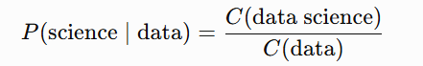
where:
- C(data Science) = Frequency of the bigram "data science"
- C(data) = Frequency of the word "data"
Calculation:
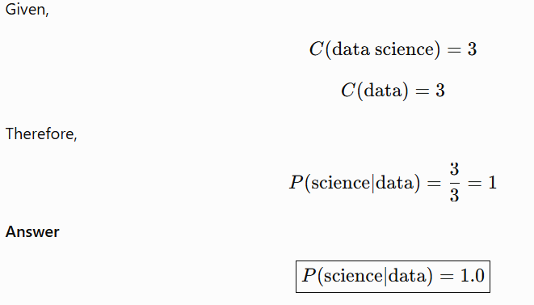
Analysis:
The calculated probability is 1.0, indicating that every occurrence of the word "data" in the training corpus is immediately followed by "science."
This means there is 100% confidence based on the available corpus that the next word after "data" is "science."
The model has learned a very strong association between these two words.

Solution / Interpretation:
In a smart mobile keyboard application, whenever the user types "data", the language model predicts "science" with the highest priority because it has the maximum probability.
This improves:
- Prediction accuracy
- Typing speed
- User experience
- Auto-completion efficiency
Since the probability is 1.0, the keyboard confidently suggests "science" as the next word.
Conclusion:
The Maximum Likelihood Estimate of the bigram probability is 1.0. This indicates a perfect association between "data" and "science" in the given corpus. MLE enables the keyboard to provide highly accurate next-word predictions, making text entry faster and more efficient.
Question 2: Apply the Backoff Model and estimate the probability for the unseen sequence "data science improves". Explain why backoff is essential for real-time predictive text systems.
Understanding of the Case:
The sequence "data science improves" does not appear in the training corpus. Therefore, the trigram probability cannot be calculated directly. To overcome this problem, the Backoff Model is used. The Backoff Model estimates the probability by moving from higher-order n-grams to lower-order n-grams until a known probability is found
Application of NLP Concepts:
The Backoff Model works as follows:
- Check whether the trigram exists.
- If the trigram is not found, use the bigram probability.
- If the bigram is also unavailable, use the unigram probability.
This approach prevents the probability from becoming zero for unseen word sequences.
Calculation:
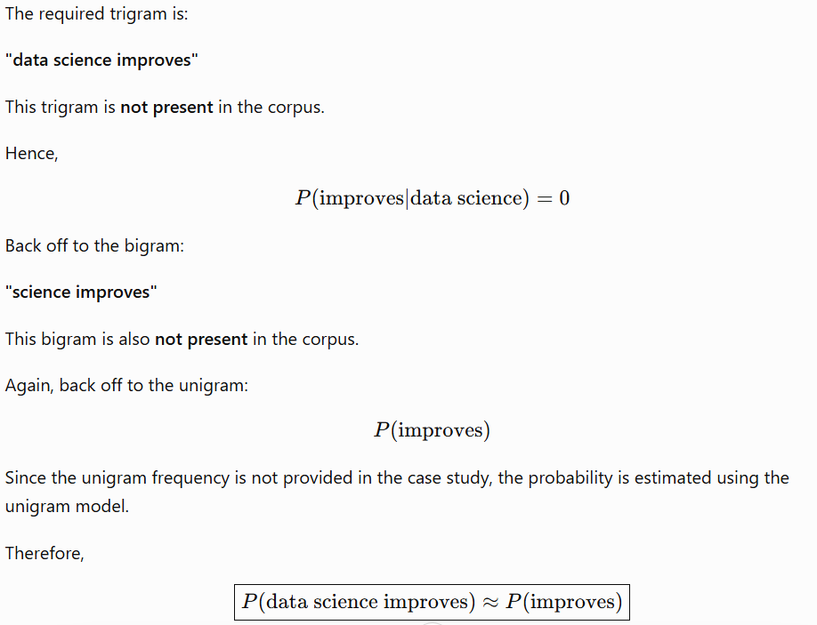
Analysis:
The trigram and bigram are unseen in the training data. Instead of assigning a probability of zero, the Backoff Model estimates the probability using a lower-order n-gram (unigram). This allows the language model to make reasonable predictions even for unseen word combinations.
Solution / Interpretation:
The Backoff Model is essential in real-time predictive text systems because:
- It avoids zero probabilities for unseen sequences.
- It improves prediction coverage.
- It allows the keyboard to suggest words even when the exact phrase has not been seen during training.
- It increases the robustness and reliability of AI-powered keyboards.
Conclusion:
The unseen sequence "data science improves" is estimated using the unigram probability through the Backoff Model. Backoff ensures continuous and reliable predictions, making mobile keyboard applications more intelligent and user-friendly.
Question 3: Using Deleted Interpolation, calculate the probability of the sequence "data science is". Discuss how interpolation balance reliability and coverage in sparse datasets.
Understanding of the Case:
Deleted Interpolation combines trigram, bigram, and unigram probabilities using predefined weights. This method provides a more reliable estimate by considering information from multiple language models.
Application of NLP Concepts:
The interpolation formula is:
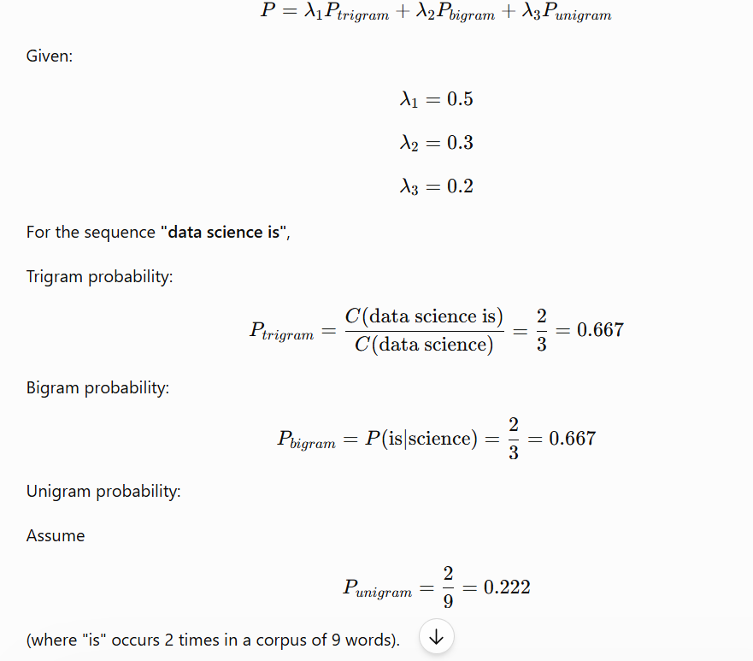
Calculation:
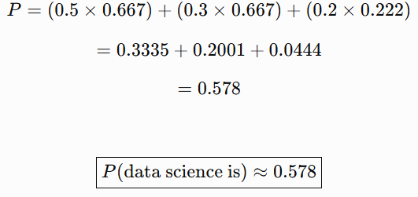
Analysis:
Deleted Interpolation combines information from three language models. The trigram contributes the highest weight because it captures more context. The bigram and unigram provide support when the higher-order model is unreliable or sparse.
Solution / Interpretation:
Interpolation improves prediction quality because:
- It reduces data sparsity.
- It prevents zero probabilities.
- It combines local and global language information.
- It improves the accuracy of next-word prediction.
This makes predictive keyboards more reliable when handling both common and rare word sequences.
Conclusion:
The interpolated probability of "data science is" is approximately 0.578. Deleted Interpolation provides a balanced and reliable probability estimate by combining trigram, bigram, and unigram models.
Question 4: Calculate the Entropy of the distribution P(is)=0.66 and P(drives)=0.33. Interpret the result and evaluate how entropy helps measure uncertainty and prediction confidence.
Understanding of the Case:
Entropy measures the uncertainty of a probability distribution. In Natural Language Processing, entropy indicates how confident the language model is when predicting the next word.
Application of NLP Concepts:
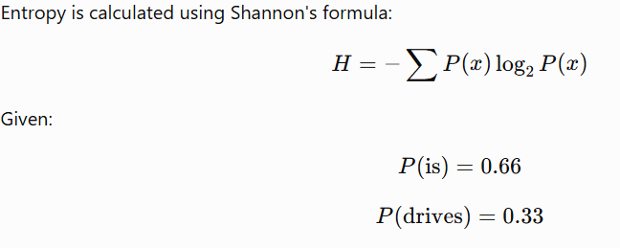
Calculation:
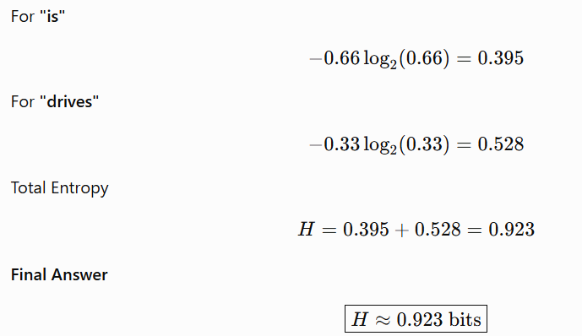
Analysis:
The entropy value is less than 1 bit, indicating relatively low uncertainty. The language model has a clear preference for the word "is" because it has a higher probability than "drives." Therefore, the prediction is fairly confident.
Solution / Interpretation:
Entropy is useful because it:
- Measures prediction uncertainty.
- Evaluates the confidence of language models.
- Helps compare different prediction models.
- Improves next-word suggestion quality in intelligent keyboards.
Lower entropy indicates higher prediction confidence, while higher entropy indicates greater uncertainty.
Conclusion:
The entropy of the given probability distribution is approximately 0.923 bits. This shows that the keyboard prediction model is reasonably confident in suggesting "is" as the next word. Entropy is an important metric for evaluating the reliability and effectiveness of intelligent text prediction systems.

CASE STUDY 2: AI-Powered Customer Support Chatbot
Question 1: Assign appropriate Penn Treebank POS tags to every word in both sentences. Justify the tag assigned to the word "book" using contextual clues.
Understanding of the Case:
The AI-powered customer support chatbot receives user messages and must identify the grammatical role of each word before generating an appropriate response. Since the word "book" can function as both a verb and a noun, the chatbot uses contextual information to determine its correct Part-of-Speech (POS) tag. The Penn Treebank POS Tagset provides standardized tags that help the chatbot understand sentence structure accurately.
Application of NLP Concepts:
Penn Treebank POS Tags Used:
POS Tag | Meaning
VB | Verb (Base Form)
DT | Determiner
NN | Noun (Singular)
JJ | Adjective
VBZ | Verb, 3rd Person Singular Present
RB | Adverb
The chatbot analyzes the surrounding words to determine whether "book" is used as a verb (action) or a noun (object).
POS Tagging:
Sentence 1
Sentence: Book a flight ticket now.
Word | POS Tag | Explanation
Book | VB | Base form verb indicating an action or command.
a | DT | Determiner modifying the noun "flight".
flight | NN | Singular noun.
ticket | NN | Singular noun acting as the object.
now | RB | Adverb indicating time.
Tagged Sentence:
Book/VB a/DT flight/NN ticket/NN now/RB
Sentence 2
Sentence: This book is interesting.
Word | POS Tag | Explanation
This | DT | Determiner referring to the noun "book".
book | NN | Singular noun referring to a reading material.
is | VBZ | Third-person singular present tense of the verb "be".
interesting | JJ | Adjective describing the noun "book".
Tagged Sentence:
This/DT book/NN is/VBZ interesting/JJ
Analysis:
The word "book" has two different meanings depending on the sentence.
- In "Book a flight ticket now.", book is used as an action, instructing the user to reserve a ticket. Therefore, it is tagged as VB (Verb).
- In "This book is interesting.", book refers to an object (a reading material). Therefore, it is tagged as NN (Noun).
The surrounding words provide the necessary context for determining the correct grammatical role of the ambiguous word.
Solution / Interpretation:
Context plays a vital role in resolving lexical ambiguity. The chatbot correctly identifies "book" as:
- VB (Verb) in the first sentence because it expresses an action.
- NN (Noun) in the second sentence because it represents an object.
Accurate POS tagging enables the chatbot to correctly understand the user's intent, leading to more accurate response generation and improved conversational performance.
Conclusion:
The Penn Treebank POS Tagset successfully assigns appropriate grammatical categories to every word in both sentences. The contextual analysis correctly identifies "book" as a verb in the first sentence and a noun in the second sentence. This demonstrates the importance of contextual POS tagging in Natural Language Processing, helping AI-powered chatbots interpret user queries accurately and generate meaningful responses.
Question 2: Using the HMM probabilities, compute the likelihood of "book" being tagged as a Verb (VB) in the sentence "Book a flight ticket now." Explain why the probabilistic model favors this tag.
Understanding of the Case:
The chatbot uses a Hidden Markov Model (HMM) to determine the most likely Part-of-Speech (POS) tag for the word "book". HMM combines transition probabilities (probability of moving from one tag to another) and emission probabilities (probability of a word being generated by a particular tag) to identify the most appropriate tag.
The given probabilities are:
- P(book | VB) = 0.6
- P(book | NN) = 0.4
- P(Start → VB) = 0.5
- P(Start → NN) = 0.5
Application of NLP Concepts:
In a Hidden Markov Model (HMM), the probability of assigning a POS tag is calculated as:
where:
- Transition Probability:
- Emission Probability:
The tag with the higher combined probability is selected as the correct POS tag.
Calculation:
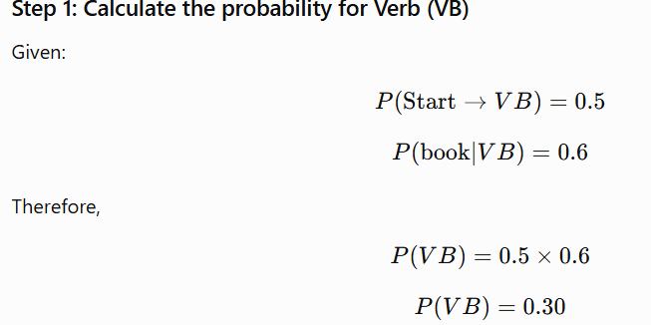
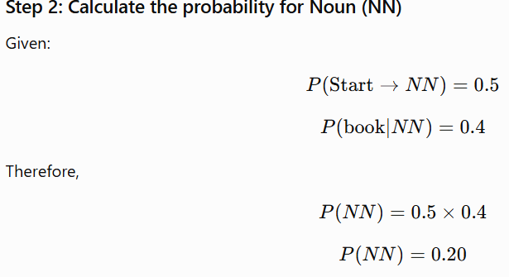
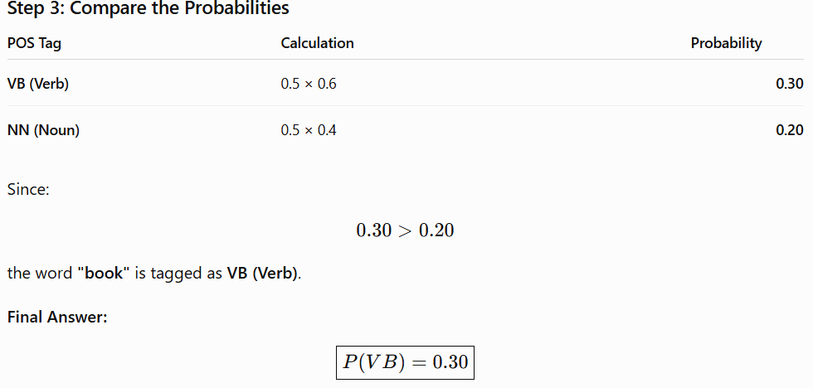
Analysis:
The probability of "book" being a Verb (0.30) is higher than the probability of it being a Noun (0.20). Therefore, the HMM selects VB as the most likely POS tag.
Additionally, the sentence "Book a flight ticket now." is an imperative sentence (a command). In such sentences, the first word is typically a verb, which further supports the probabilistic result.
Solution / Interpretation:
The HMM favors the Verb (VB) tag because:
- The emission probability of "book" as a verb (0.6) is greater than as a noun (0.4).
- The transition probabilities from the start state are equal (0.5 each), so the higher emission probability determines the final decision.
- The sentence context indicates that "book" is used as an action (to reserve a ticket), making VB the appropriate tag.
Using HMM enables the chatbot to resolve ambiguous words accurately, improving intent recognition and response generation.
Conclusion:
Using the Hidden Markov Model, the likelihood of "book" being tagged as a Verb (VB) is 0.30, which is higher than the likelihood of it being a Noun (NN) (0.20). Therefore, the chatbot correctly assigns the VB tag. HMM combines transition and emission probabilities with contextual information to improve POS tagging accuracy and enhance chatbot performance.
Question 3: Compare Rule-Based Tagging and Stochastic (HMM) Tagging in resolving lexical ambiguity. Recommend which approach is more suitable for large-scale chatbot deployment and justify your answer.
Understanding of the Case:
The chatbot must correctly identify the grammatical role of words that have multiple meanings, such as "book", which can function as both a verb and a noun. To resolve this lexical ambiguity, two common POS tagging approaches are Rule-Based Tagging and Stochastic (Hidden Markov Model - HMM) Tagging. This question requires comparing these approaches and recommending the most suitable one for large-scale chatbot deployment.
Application of NLP Concepts:
Rule-Based Tagging:
Rule-Based Tagging assigns POS tags using predefined grammatical and linguistic rules. These rules are created manually by language experts.
Example:
- If a sentence begins with "Book" followed by a noun, tag "Book" as VB (Verb).
- If "book" follows a determiner such as "this" or "the", tag it as NN (Noun).
This method depends entirely on handcrafted rules and does not learn from data.
Stochastic (HMM) Tagging:
Stochastic Tagging uses statistical models, such as the Hidden Markov Model (HMM), to assign POS tags. It calculates the most probable tag by considering:
- Transition Probability – Probability of moving from one tag to another.
- Emission Probability – Probability of a word occurring with a particular tag.
The tag with the highest overall probability is selected.
Comparison Table:
Feature | Rule-Based Tagging | Stochastic (HMM) Tagging
Working Principle | Uses manually written grammar rules | Uses probability and statistical analysis
Learning Ability | Does not learn from new data | Learns from annotated training data
Handling Ambiguity | Limited; depends on predefined rules | Effectively resolves ambiguity using probabilities
Accuracy | Good for simple sentences | High accuracy for complex and real-world sentences
Scalability | Difficult to maintain for large systems | Easily scalable for large datasets
Adaptability | Requires manual rule updates | Adapts automatically with more training data
Example | "Book" tagged using grammar rules | "Book" tagged using HMM probabilities
Analysis:
Rule-Based Tagging performs well for simple and predictable sentence structures. However, it struggles with ambiguous words and requires continuous manual updates whenever new language patterns emerge.
In contrast, HMM Tagging uses probability distributions to determine the most likely POS tag. It can effectively handle ambiguous words such as "book" by considering both context and statistical information. As the training corpus grows, the HMM model becomes more accurate and adaptable.
Solution / Recommendation:
For large-scale chatbot deployment, Stochastic (HMM) Tagging is the recommended approach because:
- It resolves lexical ambiguity more accurately.
- It handles large and diverse datasets efficiently.
- It adapts to new language patterns through training.
- It reduces the need for manually creating and updating grammatical rules.
- It improves chatbot performance in understanding user intent and generating accurate responses.
Although Rule-Based Tagging is simple and easy to implement, it is less effective for real-world conversational AI applications where language usage is dynamic and constantly evolving.
Conclusion:
Rule-Based Tagging relies on manually defined grammatical rules, while Stochastic (HMM) Tagging uses statistical probabilities to assign POS tags. HMM provides better accuracy, scalability, and adaptability for resolving lexical ambiguity. Therefore, Stochastic (HMM) Tagging is the most suitable approach for large-scale chatbot deployment, as it enhances intent detection, language understanding, and response generation in modern NLP systems.
Question 4: Evaluate the role of standardized POS tagsets and word classes in improving intent detection, response generation, and overall chatbot performance.
Understanding of the Case:
An AI-powered customer support chatbot must understand the grammatical structure of user sentences before generating appropriate responses. Standardized Part-of-Speech (POS) tagsets, such as the Penn Treebank POS Tagset, assign grammatical categories (e.g., noun, verb, adjective, adverb) to words. This enables the chatbot to correctly identify user intent, understand sentence meaning, and produce accurate responses.
Application of NLP Concepts:
Standardized POS Tagsets:
A POS tagset is a collection of predefined grammatical tags assigned to words based on their role in a sentence.
Some commonly used Penn Treebank POS tags are:
POS Tag | Meaning | Example
NN | Noun | book, ticket
VB | Verb | book, reserve
JJ | Adjective | interesting
RB | Adverb | now
DT | Determiner | a, the, this
VBZ | Verb (3rd Person Singular Present) | is
These standardized tags help NLP systems process language consistently across different applications.
Word Classes:
Words are grouped into different grammatical categories known as word classes.
Word Class | Example
Noun | flight, ticket, book
Verb | book, reserve, travel
Adjective | interesting, available
Adverb | now, quickly
Determiner | a, the, this
Identifying these word classes helps the chatbot understand the grammatical structure and meaning of user queries.
Analysis:
Standardized POS tagsets and word classes significantly improve chatbot performance in the following ways:
1. Improves Intent Detection:
POS tagging helps identify the user's intention by recognizing the role of each word.
Example:
- "Book a flight." → Book (VB) indicates a booking request.
- "This book is interesting." → Book (NN) refers to an object.
This distinction enables the chatbot to understand whether the user wants to perform an action or is referring to a noun.
2. Enhances Response Generation:
By identifying nouns, verbs, adjectives, and other word classes, the chatbot can generate grammatically correct and contextually appropriate responses.
Example:
User: "Book a flight to Delhi."
Chatbot: "Your flight booking has been initiated."
Correct POS tagging ensures that the chatbot understands the request accurately before generating a response.
3. Resolves Lexical Ambiguity:
Many English words have multiple meanings depending on context.
Example:
- Book as VB (Verb) → Reserve a ticket.
- Book as NN (Noun) → Reading material.
POS tagging uses contextual information to assign the correct grammatical role, reducing ambiguity and improving language understanding.
4. Improves Overall Chatbot Performance:
Standardized POS tagging contributes to:
- Better language understanding.
- More accurate intent classification.
- Improved response quality.
- Reduced grammatical errors.
- Higher user satisfaction.
- Consistent performance across different domains and applications.
Solution / Interpretation:
Using standardized POS tagsets allows the chatbot to analyze sentence structure consistently and accurately. By correctly identifying word classes, the chatbot can understand user intent, resolve ambiguous words, and generate meaningful responses.
This results in:
- Faster processing of user queries.
- Improved conversational accuracy.
- Better customer experience.
- More reliable decision-making in customer support applications.

Conclusion:
Standardized POS tagsets and word classes play a vital role in Natural Language Processing by enabling chatbots to understand sentence structure and word functions accurately. They improve intent detection, response generation, lexical ambiguity resolution, and overall chatbot performance. Therefore, using standardized POS tagging is essential for developing intelligent, accurate, and efficient AI-powered customer support chatbots.

CASE STUDY 3 – News Analytics and POS Tag Correction System
Question 1: Apply the transformation rule and update the POS tag sequence. Explain why the correction is linguistically appropriate.
Understanding of the Case:
A digital news analytics company processes millions of news articles every day. Initially, the sentence is tagged using a POS tagger, but some tags may be incorrect. To improve accuracy, the system uses a Transformation-Based Tagger (Brill Tagger), which applies learned grammatical rules to correct incorrect POS tags.
The given sentence is:
Economic growth increases employment.
Initial POS Tags:
Word | Initial POS Tag
Economic | JJ
growth | NN
increases | NNS
employment | NN
Transformation Rule:
Change NNS to VBZ if the preceding word is tagged as NN.
Application of NLP Concepts:
A Transformation-Based Tagger (Brill Tagger) first assigns initial POS tags using a basic tagging method. It then applies transformation rules learned from annotated data to improve tagging accuracy.
In this case, the rule is:
- If a word is tagged as NNS (Plural Noun) and the previous word is tagged as NN (Singular Noun),
- Then change NNS to VBZ (Verb, 3rd Person Singular Present).
This rule helps correct grammatical errors based on sentence context.
Applying the Transformation Rule:
Initial POS Tag Sequence;
Word | Initial Tag
Economic | JJ
growth | NN
increases | NNS
employment | NN
The word "increases" is tagged as NNS.
The preceding word is "growth", which is tagged as NN.
According to the given transformation rule:
Change NNS → VBZ if the previous tag is NN.
Therefore,
increases/NNS → increases/VBZ
Updated POS Tag Sequence:
Word | Updated POS Tag
Economic | JJ
growth | NN
increases | VBZ
employment | NN
Final Tagged Sentence:
Economic/JJ growth/NN increases/VBZ employment/NN
Analysis:
Initially, the word "increases" was incorrectly tagged as NNS (Plural Noun). However, in the sentence:
Economic growth increases employment.
the word "increases" functions as the main verb, describing the action performed by the subject "economic growth."
Since "growth" is a singular noun (NN), the verb should be in the third-person singular present tense (VBZ). Therefore, changing the tag from NNS to VBZ makes the sentence grammatically correct.
Solution / Interpretation:
The Transformation-Based Tagger successfully improves the POS tagging by applying the learned transformation rule.
The correction provides several benefits:
- Improves grammatical accuracy.
- Correctly identifies the action (verb) in the sentence.
- Enhances sentence understanding.
- Improves the performance of downstream NLP tasks such as parsing, information extraction, and text analysis.
The corrected POS sequence is:
Economic/JJ growth/NN increases/VBZ employment/NN
which accurately represents the grammatical structure of the sentence.
Conclusion:
By applying the transformation rule, the incorrect tag NNS is changed to VBZ, resulting in the corrected POS sequence:
Economic/JJ growth/NN increases/VBZ employment/NN
This correction is linguistically appropriate because "increases" acts as the main verb describing the action performed by the singular subject "growth." Transformation-Based Tagging effectively improves POS tagging accuracy by using contextual grammatical rules, making NLP systems more reliable for real-world text analysis.
Question 2: Analyze the initial tagging errors and justify the corrected tag assignments using grammatical structure and sentence semantics.
Understanding of the Case:
The sentence "Economic growth increases employment." was initially tagged using an automatic POS tagger. However, the initial tagging contains an error because the word "increases" is incorrectly identified as a plural noun (NNS) instead of a verb (VBZ). The task is to analyze the tagging error and justify the corrected POS tags using grammatical structure and sentence meaning (semantics).

Application of NLP Concepts:
Part-of-Speech (POS) tagging assigns grammatical categories to words based on their function in a sentence. Sometimes, an automatic tagger may assign incorrect tags due to lexical ambiguity. A Transformation-Based Tagger (Brill Tagger) applies contextual rules to correct these errors.
The corrected POS tags should accurately represent the grammatical structure of the sentence.
Initial and Corrected POS Tags:
Word | Initial POS Tag | Corrected POS Tag | Reason
Economic | JJ | JJ | "Economic" describes the noun "growth", so it is an adjective.
growth | NN | NN | "Growth" is the subject of the sentence and is a singular noun.
increases | NNS | VBZ | "Increases" expresses the action performed by "growth", so it is a verb in the third-person singular present tense.
employment | NN | NN | "Employment" is the object of the verb and is a singular noun.
Analysis:
The initial tagging error occurs with the word "increases."
Error Analysis
Initially:
increases → NNS (Plural Noun)
This tag is incorrect because "increases" is not functioning as a noun in the sentence.
Consider the sentence:
Economic growth increases employment.
Here,
- Economic growth is the subject.
- Increases describes the action performed by the subject.
- Employment is the object receiving the action.
Therefore, "increases" functions as the main verb and should be tagged as VBZ (Verb, Third-Person Singular Present).
Grammatical Structure:
The sentence follows the Subject – Verb – Object (SVO) pattern.
Sentence Part | Word
Subject | Economic growth
Verb | increases
Object | employment
Since growth is a singular noun (NN), the verb must also be in the singular present form (VBZ). This confirms that the corrected tag is grammatically accurate.
Sentence Semantics:
Semantics refers to the meaning conveyed by the sentence.
The sentence means:
Economic growth leads to an increase in employment.
Here, "increases" expresses an action or process rather than referring to a plural noun. Therefore, assigning the VBZ tag preserves the intended meaning of the sentence.

Solution / Interpretation:
After correcting the tagging error, the POS sequence becomes:
Economic/JJ growth/NN increases/VBZ employment/NN
This corrected sequence accurately reflects both the grammatical structure and the semantic meaning of the sentence.
The corrected tags help NLP systems perform tasks such as:
- Syntax analysis
- Dependency parsing
- Information extraction
- Text summarization
- Machine translation
- News analytics
with greater accuracy.
Conclusion:
The initial POS tagging incorrectly labeled "increases" as NNS (Plural Noun). By analyzing the grammatical structure and sentence semantics, it is correctly changed to VBZ (Verb, Third-Person Singular Present). The corrected POS sequence,Economic/JJ growth/NN increases/VBZ employment/NN, accurately represents the sentence structure and meaning. This demonstrates how Transformation-Based Tagging improves POS tagging accuracy and enhances the performance of NLP applications such as news analytics and language understanding.
Question 3: Assuming the corpus contains the words:
- economic = 120 occurrences
- growth = 450 occurrences
- increases = 210 occurrences
- employment = 380 occurrences
Compute the word frequency distribution and explain how frequency information supports probabilistic POS tagging.
Understanding of the Case:
A news analytics system processes a large collection of news articles (corpus). The frequency of each word in the corpus is used to calculate its probability of occurrence. These probabilities help probabilistic POS tagging models, such as the Hidden Markov Model (HMM), assign the most likely grammatical tag to each word.
Application of NLP Concepts:
Word Frequency Distribution measures how often each word appears in the corpus.
The probability of a word is calculated using the formula:
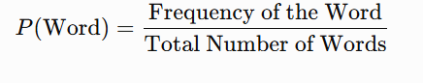
Given Frequencies
Word | Frequency
economic | 120
growth | 450
increases | 210
employment | 380
Total Number of Words:
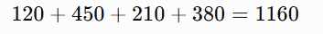
Calculation:
Step 1: Calculate the Probability of Each Word

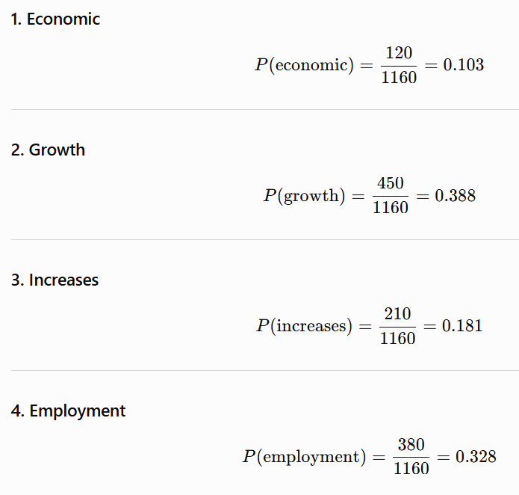
Word Frequency Distribution Table:
Word | Frequency | Probability
Economic | 120 | 0.103
Growth | 450 | 0.388
Increases | 210 | 0.181
Employment | 380 | 0.328
Total | 1160 | 1.000
Analysis:
From the frequency distribution:
- Growth has the highest frequency (450 occurrences) and the highest probability (0.388).
- Employment is the second most frequent word with a probability of 0.328.
- Increases has a probability of 0.181.
- Economic has the lowest frequency and probability (0.103).
Higher-frequency words generally have more reliable statistical information, enabling probabilistic models to assign POS tags with greater confidence.
Solution / Interpretation:
Word frequency information supports probabilistic POS tagging in several ways:
- It estimates the probability of each word occurring in the corpus.
- Frequently occurring words provide more reliable statistical evidence for assigning correct POS tags.
- Frequency data helps resolve ambiguity by selecting the most probable grammatical category based on observed usage.
- It improves the accuracy of probabilistic models such as the Hidden Markov Model (HMM) and other statistical taggers.
- It enhances the overall performance of NLP applications such as news analytics, information extraction, and text classification.
Conclusion:
The total number of words in the corpus is 1160. The calculated word probabilities are:
- Economic = 0.103
- Growth = 0.388
- Increases = 0.181
- Employment = 0.328
These probabilities form the word frequency distribution, which provides statistical information for probabilistic POS tagging. By using word frequencies, NLP systems can assign more accurate grammatical tags, reduce ambiguity, and improve the performance of news analytics and other language processing applications.
Question 4: Evaluate how Transformation-Based Tagging improves tagging accuracy compared with the initial tagging stage. Discuss how entropy can be used to measure uncertainty in tag assignments before and after rule application.
Understanding of the Case:
The news analytics system initially assigns POS tags using a basic tagger. However, some words may receive incorrect tags due to ambiguity. To improve accuracy, the system applies Transformation-Based Tagging (Brill Tagger), which uses learned linguistic rules to correct incorrect POS tags. Entropy is then used to measure the uncertainty in the tagging process before and after applying these rules.
Application of NLP Concepts:
Transformation-Based Tagging (Brill Tagger):
Transformation-Based Tagging is a rule-based machine learning approach that improves an initial POS tagging result by applying learned transformation rules.
For the given sentence:
Economic growth increases employment.
Initial POS Tags:
- Economic/JJ
- Growth/NN
- Increases/NNS
- Employment/NN
Transformation Rule:
Change NNS to VBZ if the preceding word is tagged as NN.
After applying the rule:
- Economic/JJ
- Growth/NN
- Increases/VBZ
- Employment/NN
The incorrect tag NNS is successfully corrected to VBZ.
Entropy in POS Tagging:
Entropy is a statistical measure of uncertainty in a probability distribution.
The entropy formula is:
- High entropy indicates greater uncertainty in tag assignment.
- Low entropy indicates higher confidence in the assigned tags.
After applying transformation rules, the system becomes more confident in selecting the correct POS tags, which reduces entropy.
Analysis:
Initial Tagging Stage:
The initial tagger incorrectly classified "increases" as a plural noun (NNS). This error creates ambiguity because the sentence structure suggests that "increases" functions as the main verb.
As a result:
- Tagging accuracy is lower.
- Uncertainty is higher.
- Entropy is relatively high because the system is less confident about the correct tag.
After Applying Transformation Rule:
The Transformation-Based Tagger changes:
NNS → VBZ
The corrected sentence becomes:
Economic/JJ Growth/NN Increases/VBZ Employment/NN
This correction matches both the grammatical structure and the meaning of the sentence.
As a result:
- Tagging accuracy increases.
- Context is interpreted correctly.
- Ambiguity is reduced.
- Entropy decreases because the system is more confident in its tag assignments.
Comparison Table:
Feature | Initial Tagging | After Transformation-Based Tagging
Tag for "increases" | NNS (Incorrect) | VBZ (Correct)
Grammatical Accuracy | Low | High
Context Understanding | Limited | Accurate
Tagging Confidence | Low | High
Entropy | High (More Uncertainty) | Low (Less Uncertainty)
Overall Accuracy | Lower | Higher
Solution / Interpretation:
Transformation-Based Tagging improves NLP performance by:
- Correcting incorrect POS tags using contextual rules.
- Reducing lexical ambiguity.
- Improving grammatical accuracy.
- Enhancing syntactic analysis.
- Increasing the reliability of downstream NLP tasks such as information extraction, machine translation, text summarization, and news analytics.
Entropy acts as a quality measure by indicating the confidence of the tagging system.
- Before rule application: High entropy reflects uncertainty and possible tagging errors.
- After rule application: Lower entropy reflects improved confidence and more accurate POS tagging.
Conclusion:
Transformation-Based Tagging significantly improves POS tagging accuracy by correcting errors based on learned contextual rules. In this case, the incorrect tag NNS is successfully changed to VBZ, producing a grammatically correct tag sequence. This correction enhances sentence understanding and overall NLP performance. Additionally, entropy provides a useful measure of uncertainty: higher entropy before rule application indicates lower confidence, while lower entropy after rule application indicates higher confidence and improved tagging accuracy.

Rubrics for Calculation

Criteria | Weightage | Level 4 – Exemplary | Level 3 – Proficient | Level 2 – Developing | Level 1 – Beginning
Understanding of Case | 25 | Thorough understanding; clearly identifies all key issues | Good understanding with most issues identified | Basic understanding; some issues missed | Poor understanding; problem not identified correctly
Application of Concepts | 25 | Effectively applies relevant concepts to analyze the case deeply | Applies appropriate concepts with minor gaps | Limited application of concepts | Fails to apply relevant concepts
Analysis | 20 | In-depth analysis with strong reasoning and insights | Good analysis with logical reasoning | Basic analysis with limited depth | Weak or no analysis; lacks reasoning
Solution Design | 20 | Innovative, feasible solutions with strong justification | Logical solutions with adequate justification | Basic solutions with weak justification | Incorrect or no solution provided
Clarity | 10 | Clear, well-structured, and easy to understand | Organized and understandable presentation | Limited clarity and structure | Poor clarity; difficult to understand

Q. No. / Criteria Level | Understanding of Case | Application of Concepts | Analysis | Solution Design | Clarity | Sub. Total | Total %
1
2
3

Faculty In-charge | Course Coordinator | Program Director
Signature: _______________ | Signature: _______________ | Signature: _______________
Date: ___________________ | Date: ___________________ | Date: ___________________

